14, Aug, 2020

IT PRACTICAL solutions

**QUESTION 1**

<!DOCTYPE html>

<html lang="en" dir="ltr">

<head>

<meta charset="utf-8">

<title>area of triangle</title>

</head>

<body>

<script type="text/javascript">

var a = parseInt(prompt("side A"),"");

var b = parseInt(prompt("side B"),"");

var c = parseInt(prompt("side C"),"");

var s=(a+b+c)/2;

var ar= Math.sqrt(s*(s-a)*(s-b)*(s-c));

document.write("area is"+ ar);

</script>

</body>

</html>

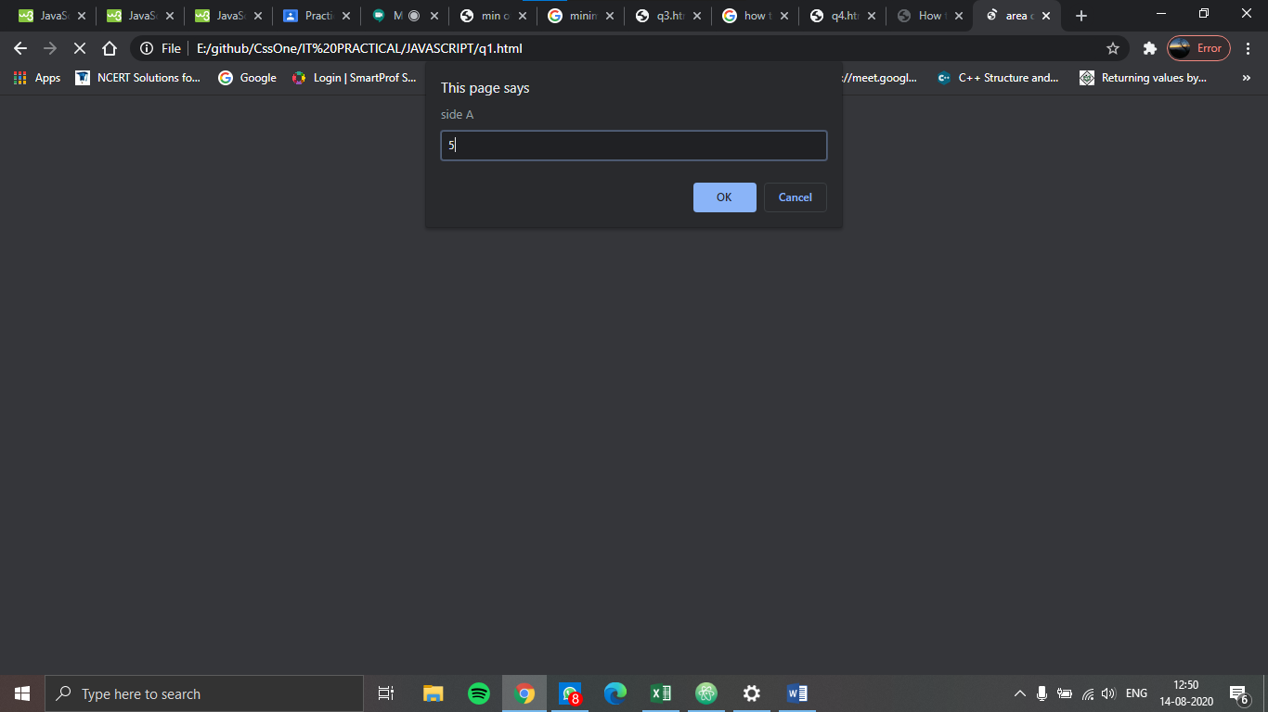

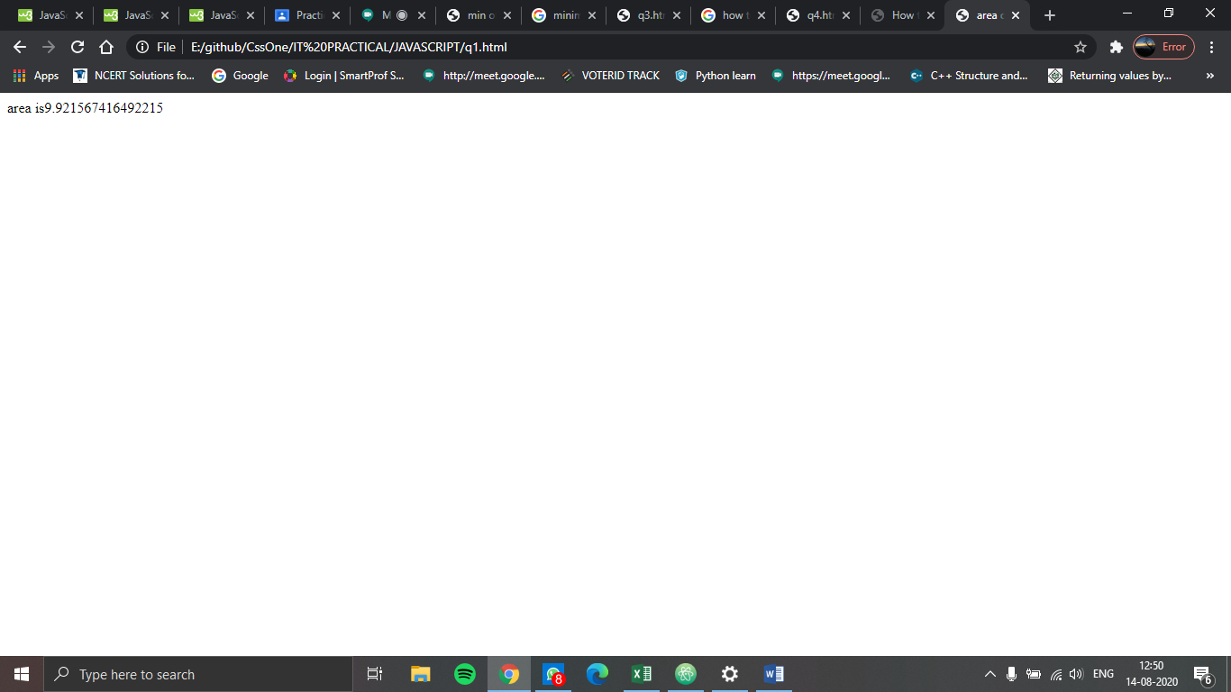

**QUESTION 2**

**<!DOCTYPE html>**

**<html lang="en" dir="ltr">**

**<head>**

**<meta charset="utf-8">**

**<title>min of array</title>**

**</head>**

**<body>**

**<script type="text/javascript">**

**//var arr = new Array();**

**min=1e8; //MAX_VALUE not working here**

**for(var i=0;i<10;i++)**

**{**

**var a = parseInt(prompt("enter number"),"");**

**if(a<min)**

**{**

**min=a;**

**}**

**}**

**//var return= Math.mini(arr);**

**document.write("min is"+ min);**

**</script>**

**</body>**

**</html>**

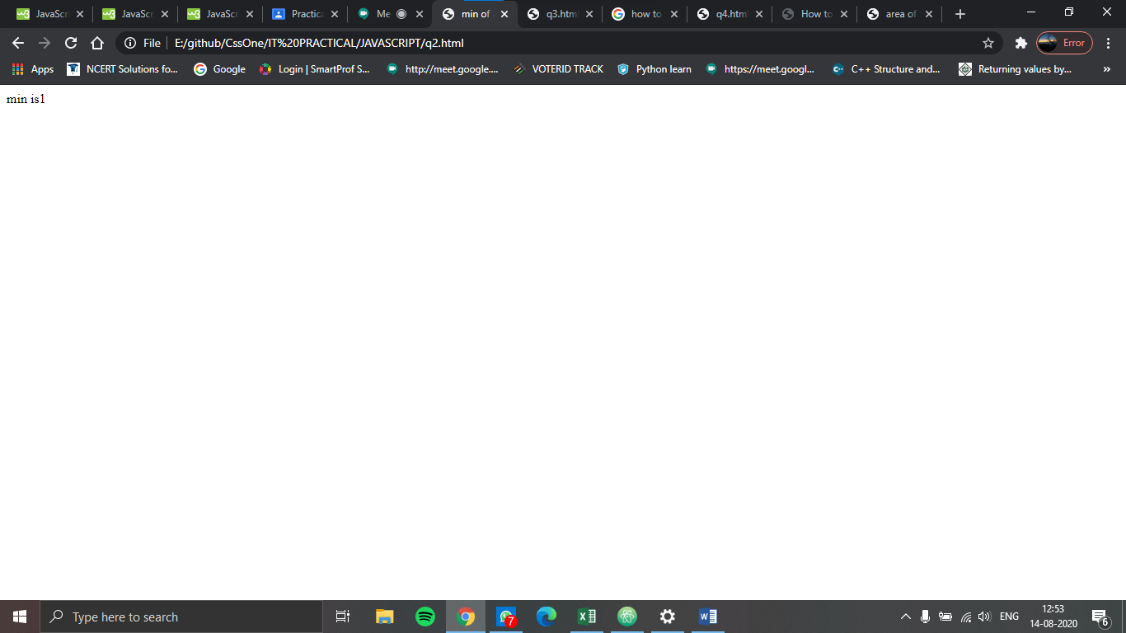

**QUESTION 3**

<!DOCTYPE html>

<html lang="en">

<head>

<meta charset="utf-8">

</head>

<body>

<script type="text/javascript">

var f = ["One", "Ten", "Five", "Nine"];

var e = f.join("+");

document.write("F is " + f);

document.write("<br>e is " + e);

f.splice(2, 0, "New", "New2");

document.write("<br> New F after splicing is " + f);

var x = f.toString();

document.write("<br>F tostring is " + x);

f.sort();

document.write("<br>F after sorting is " + f);

</script>

</body>

</html>

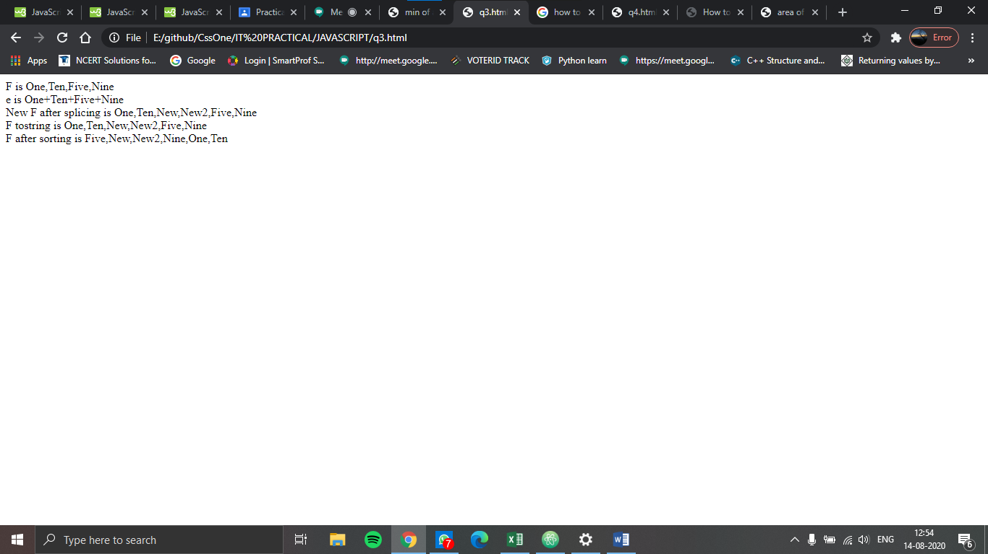

**QUESTION 4**

**<html>**

**<body>**

**<script type=" text/javascript">**

**var arr1 = [];**

**var arr2 = [];**

**var size1 =parseInt(prompt("enter size of array 1", "size"));**

**var size2 =parseInt(prompt("enter size of array 2", "size"));**

**for(var i=0 ; i<size1 ; i++)**

**{**

**arr1[i]=parseInt(prompt("enter element of array1",(i+1) + "th element"));**

**}**

**for(var i=0 ; i<size2 ; i++)**

**{**

**arr2[i]=parseInt(prompt("enter element of array2",(i+1) + "th element"));**

**}**

**function mergearray(arr1,arr2,size1,size2)**

**{**

**var a=0;**

**var arr3=[];**

**size3 = size1+size2;**

**for(i=0; i<size1;i++)**

**{**

**arr3[a]=arr1[i];**

**a++;**

**}**

**for( var j=0;j<size2; j++)**

**{**

**arr3[a]=arr2[j];**

**a++;**

**}**

**for(var i=0;i<size3;i++)**

**{**

**for(var j=0;j<size3;j++)**

**{**

**if(arr3[j+1]<arr3[j])**

**{**

**var temp = arr3[j];**

**arr3[j]= arr3[j+1];**

**arr3[j+1]=temp;**

**}**

**}**

**}**

**return(arr3);**

**}**

**document.write(mergearray(arr1,arr2,size1,size2));**

**</script>**

**</body>**

**</html>**

